The text file which have entries in the form of key/value pairs is called properties file. The property file can have any extension but recommended to take .properties extension.

Java.util.Properties is sub class of java.util.Hashtable. This object can hold strings as key and value. This class has load(-,-) method which copy entries from property file to elements of java.util.Properties object.

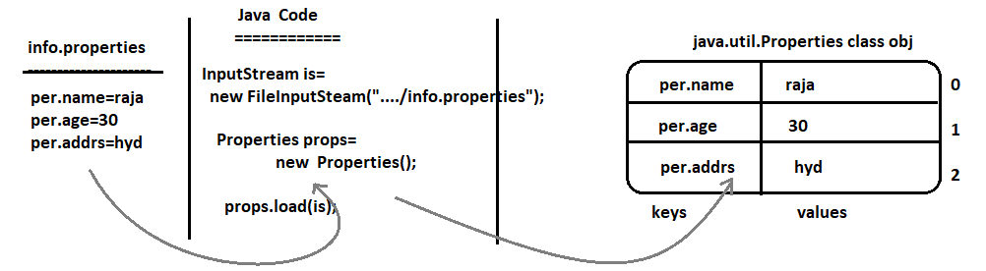

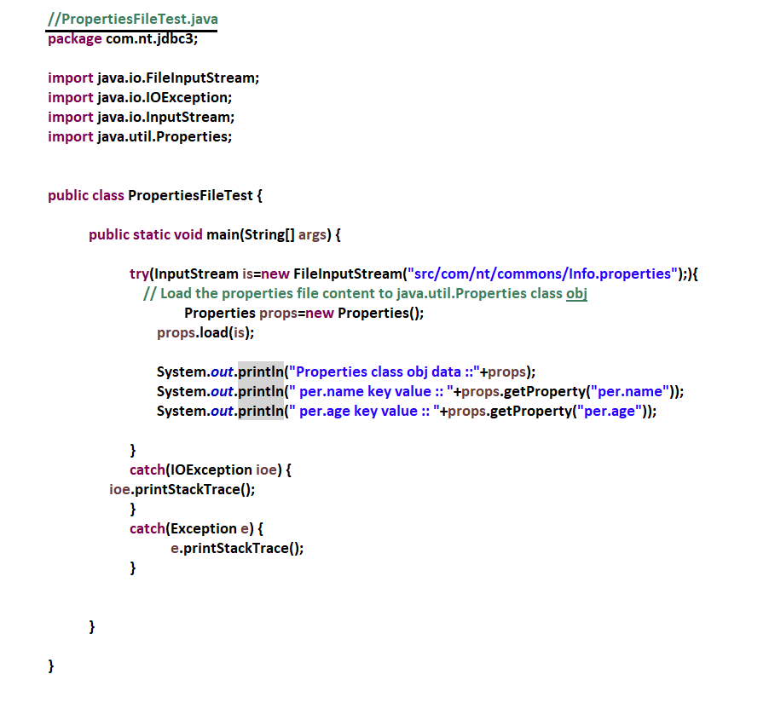

Note:- JDBC Driver classname, DB url, DBUsername, DB password are JDBC properties. You don’t hard code them in JDBC application. It is recommended to get them from outside the application using Softcoding. So we have to change them time to time based on JDBC driver changed, DB changed. In this process, we use property file to get the JDBC properties.